

CS306 – Database Management Project Report
Airline System Reservation
Professor: Dr. Kazeem Oladejo
Students: Hena Čavkušić, Bajram Plavović

Sarajevo, 2026
1.Introduction
Project Airline System Reservation represent modern airline operations and passengers data management. It manages essential operations for air traffic. System is used for organizing, storing and processing data for flight lines, passengers, bookings, employees, staff, airports, airplanes and other operations. Efficient database system allows airlines to manage reservations, observe schedules and bookings, verify and trach seat availability, generate reports according to operational and bussines analysis.
Whole purpose of this project is implementation of relational database for project using MySQL. Focus is on proper and useful database design, usage of normalization, implementing relationships between entities and SQL queries for data manipulation and reportings. Additionally, Metabase is utilized for creating visual representations of query results and analytics.

2.Objectives
Main objective of the project is to create a relational database that is capable of managing reservation operations properly. Objectives include:
2.1.Designing a Normalized Relational Database
Main objective was to design and create normalized and relational database that is properly structured and that fits to its purpose of managing airline reservations. As previously mentioned, database was normalized, redundancy is reduced and data consistency was improved and efficient organization of inserted data is properly ensured.
2.2.Managing Flight, Passenger, Airport, Aircraft, Employees and Booking Data
System was designed to store and manage airlines-related data such as flight lines, passengers, airports, bookings, employees and aircrafts. Such a design allows easy and efficient handling of operations, retrieval of informations and ensures smooth access to data trough SQL queries.
2.3.Implementing Primary and Foreign Keys
Primary and foreign keys were implemented to establish and create proper relationships between entities and to maintain interity of whole concept of database design. Those releationships are ensuring that all data remains consistent and linked correctly troughout whole system.
2.4.Preventing Data Redundant and Incosistent Data
Important aspect of designing data is to lower down to zero duplicated, incosistend or redundant data inside of database. Trough proper declaration of entities and normalization, desing is improved to highest reliability of usage.
2.5.Supporting Booking and Payment Management
Database supports bookings and payments for flight. This aspect of implementation allows system to connect passengers, flights, seat reservations and payment details.
2.6.Creating Reports and Visualizations
Project includes SQL queries and Metabase visualizations for generating meaningful reports and analytics. Reports are demonstrating practical use of Airline Reservation System.
2.7.Demonstrating Practical Database Management Skills
The project demonstrates practice of using relational database system, queries and other aspects of proper management of database such as normalizations, relations and design principles. Project also introduces implementations of junction tables for handling many-to-many relations and provides hands-on experience with MySQL, Metabase, ER Diagrams and implementations of business rules.
3. User Requirements
System is intended for airline staff and database administratiors who want to manage and analyze airline operations data efficiently. Users interact with database to hold accurate records and support everydays airline operations.
3.1.Update Existing Flight or Passenger Information
System should allow changes of existing records when change occurs. Users can update flight schedules, passenger details, statuses, employee assignments or other informations
3.2.Delete Records When Necessary
System should allow users ability to remove outdated data from the database when it is required.
3.3.Search and Retrieve Informations Using SQL Queries
Database should support efficient searching and retrieval of informations trough SQL queries. Users can check details related to each of entities represented in database.
3.4.Generate Reports Related to Passenger Counts
Users should be able to check reports that represents the number of passengers assigned to each flight. These reports are helping to analyze flight demands properly and distribute passengers accross routes.
3.5.Generate Reports Related to Flight Occupancy
System should be able to provide informations to users about seat occupancy and booking levels for flights. It will allow proper monitoring of aircraft usage and flight capacity.
3.6.Generate Reports Related to Revenue Analysis
Database is designed to provide revenue analysis trough payment and booking data. Users can generate reports showing total revenue per flight, air company or booking category.
3.7.Generate Reports Related to Delayed Flights
System should provide analytical reports showing delayed flights and delay durations for practical purposes of operational efficiency and identifying potential scheduling issues.
3.8.Generate Reports Related to Airport and Airline Activity
Users should be able to check analytical reports of airport and airline activites using flight and booking data. Those reports are identifying most used routes, aircrafts, airlines or airports within the system
4.Business Rules
The following business rules are implemented in the Airline Reservation System database:
4.1.Each Flight Must Have a Unique Identifier
Every flight in system has unique identifier and flight number assigned. Those identifiers are ensuring that flights can be uniquely recognized and managed without conflicts or duplications.
4.2.Each Flight Has One Departure and One Arrival Airport
Each flight is assigned with only one departure and arrival airport. This relationship allows system to manage flight destinations properly with high accuracy.
4.3.Each Aircraft Has a Fixed a Seating Capacity
Each aircraft in the database has previously defined capacity of seats based on aircraft model. Such informations are used for proper monitoring of seat availability and prevent potential overbookings
4.4.Each Flight Is Assigned To Exactly One Aircraft
A flight can use one aircraft at specific time. Rule is defined to ensure potential route missmatching.
4.5.Passenger Can Have Multiple Bookings
Naturally, passengers are allowed to have many bookings within the system, and it is carefully handled with relationship that supports trips, connecting flights and reservations.
4.6.Each Booking Belongs To Exactly One Passenger and One Flight
Every booking is assigned to one passenger and one flight. This rule ensures that booking informations remain organized and trackable.
4.7.Airports Must Have Unique Airport Codes
Each airport has unique airport code which are realistic such as SJJ – Sarjaevo inernational airport. Codes are preventing confusion and allow accurate identification of airports.

4.8.Flights Cannot Use The Same Aircraft At Overlapping Times
As it is physically impossible, it is ensured that it is impossible in database. Aircraft cannot be assigned to multiple flights that overlap in time which is ensuring realistic scheduling and prevent time clashes.
4.9.Deleting a Flight Also Deletes Associated Bookings
When a flight is removed from data, all bookings related to deleted flight are automatically deleted using cascading delete rules.
4.10.Employees Can Work On Multiple Flights
Employees can be assigned to multiple flights, while each flight can also include multiple employees. This many-to-many relationship is handled by using junction table.
5. Database Design
The database was designed using relational model. The system contains the these tables:
5.1.Airports
The Airports table stores data about airports used inside Airline Reservation System. Atributes inside table includes AirportID, AirportCode, AirportName, City and Country. After inserted data, following table looks like this:
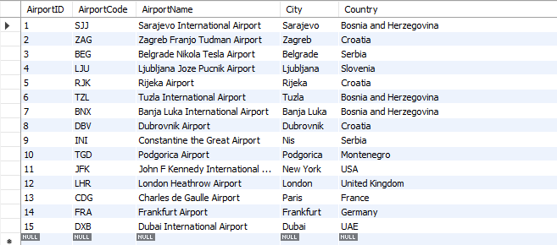
Figure 1.1. Airport table with inserted data
5.2.Aircrafts
The Aircraft table stores informations about models, manufacturers and seating capacities. Aircraft table atributes include AircraftID, AircraftModel, Manufacturer and Capacity. After inserted data, Aircraft table looks like this:
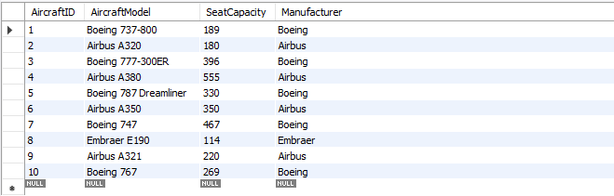
Figure 1.2. Aircraft table with inserted data
5.3.Airlines
The Airlines table stores data related to airline companies and its flight operations inside whole system. Atributes included are AirlineID, AirlineName and Country. Airlines table after inserted data is showed bellow:
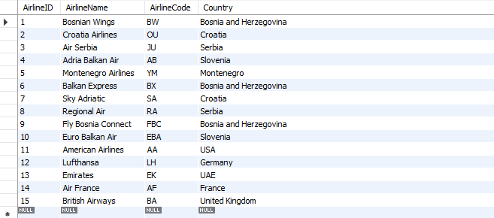
Figure 1.3.Airline table with inserted data
5.4.Passengers
The Passengers table contains information about passengers and bookings-related details. Atributes inside Passengers table are PassengerID, FirstName, LastName, PhoneNumber, Email and Nationality. Passenger table is represented below, after inserted data:
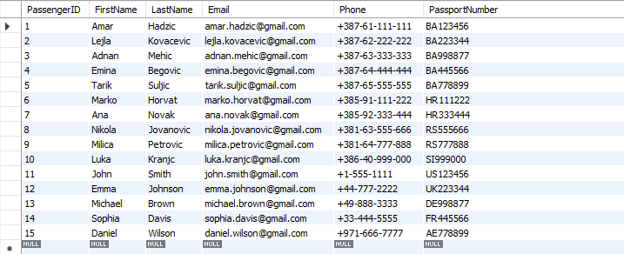
Figure 1.4. Passengers table with inserted data
5.5.Employees
The Employees table stores data about airline employees asigned to flights and other operations. Atributes included are EmployeeID, FirstName, LastName , Position, Phonenumber and Email. Employees table after inserted data is showed bellow:
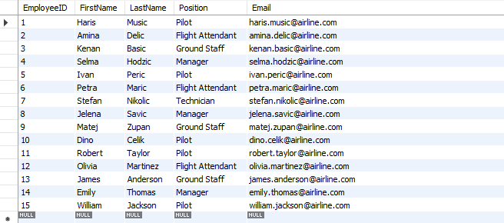
Figure 1.5. Employees table with inserted data
5.6.Flights
Table called Flights represents the central entity of the whole database and stores data related to flights. Its attributes are FlightID, FlightNumber, DepartureAirportID, ArrivalAirportID, AircraftID, AirlineID, DepartureTime, ArrivalTime, FlightStatus and DelayMinutes. This table conncets airports aircrafts, airlines, bookings and employees. Flights table after inserted data looks like this:
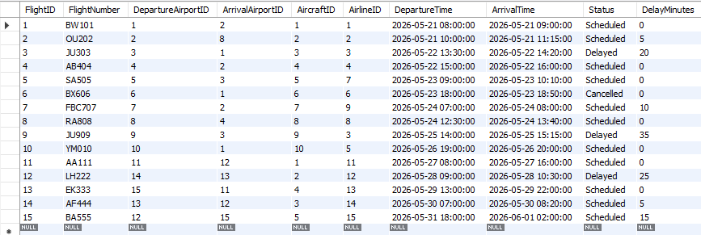
Figure 1.6.Flights table with inserted data
5.7.Bookings
The Bookings table contains passenger reservation data for flights. Attributes introduced in Bookings table are BookingID, PassengerID, FlightID, SeatNumber, SeatClass and BookingStatus. Bookings table is showed bellow after inserted data:
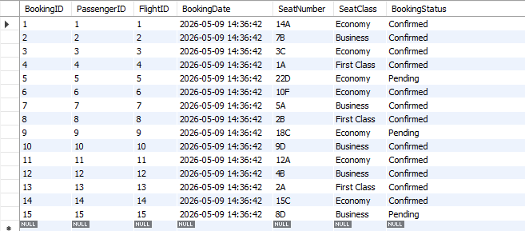
Figure 1.7.Bookings table with inserted data
5.8.Payments
The Payments table contains transaction and payment details related to bookings. Its atributes include PaymentID, BookingID, Amount, PaymentDate. Payments table is presented below after proper data is inserted.
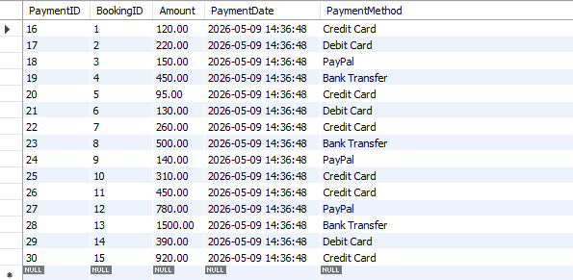
Figure 1.8. Payment table with inserted data
5.9.FlightEmployees
The FlightEmployees table is additionally introduced junction table used to manage and handle many-to-many relations between flights and employees table more easily. Its attributes are FlightEmployeeID, FlightID, EmployeeID and RoleOnFlight. FlightEmployees table with its inserted data is presented bellow:
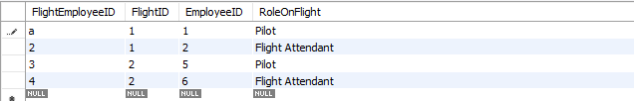
Figure 1.9.FlightEmployees table with inserted data

As previously mentioned, the central part or entity of whole database is Flights table that connects the most of other tables. In addition primary and foreign keys were implemented to ensure integrity and consistency of data and proper relationships between tables.

6.Entity Relationship Diagram (ERD)
The Entity Relationship Diagram represents the database structure and relationship between entities. ERD of Airline Reservation System database is represented bellow:
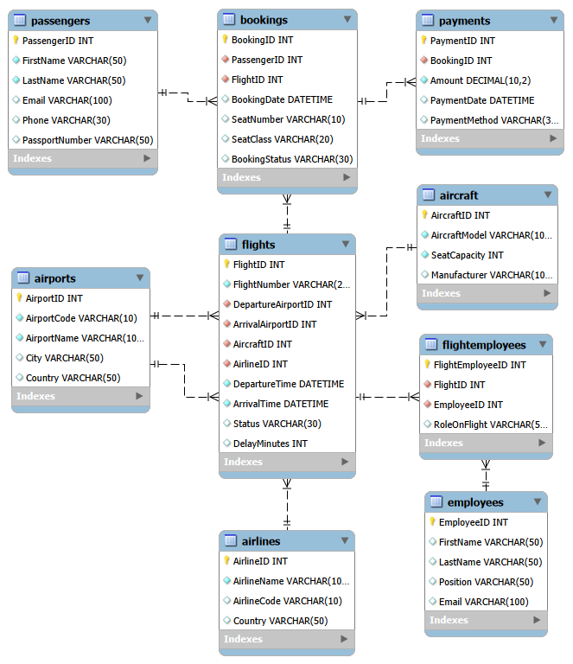
Figure 2.1. Entity Relationship Diagram

The database includes one-to-many relationships which are resolved with proper usage of primary and foreign keys. And introduced many-to-many relationship is resolved by introducing junction table FlightsEmployees which is previously mentioned.
Introduced one-to-many relationships are:
- passengers → bookings
- flights → bookings
- bookings → payments
- airlines → flights
- airports → flights
And there is introduced many-to-many relationship:
- flights ↔ employees
7.Normalization
Database design follows principles of normalization in order to secure minimal redundancy, improve consistent data flow and organization.
7.1.First Normal Form (1NF)
Airline Reservation System database satisfies 1NF because each table contains primary key and all attributes store atomic values. No repeating groups or multiple values are stored within single column.
For example from database, in the Passengers table, each passenger has seperate attributes such as FirstName, LastName, PhoneNumber and Email. The system does not store multiple emails or numbers inside a single field for instance.
7.2. Second Normal Form (2NF)
The database follows 2NF principles because all non-key attributes depend completely on the primary key of their table.
Example in data is passengers informations such as name and email is stored only in certain table, Passengers as it is in database and not repeated in other tables such as Bookings table. The Bookings table only storess PassengerID foreign key that refferences to passenger data.
Similarly, aircraft details are stored in Aircraft table, while Flights table only references the aircraft details trough AircraftID.
7.3.Third Normal Form (3NF)
Database also satisifes principles of 3NF because transitive dependecies are reduced completely and redundant informations are seperated into dedicated tables.
Example from data are informations about airlines stored seperately in Airlines tables instead of repeating airline names in every flight record. Flights only contains AirlineID as a foregin key that refferences to Airline data.
8.SQL Implementation
The database was implementeng using MySQL as the main relational database management system. SQL scripts were used to create tables, define relationships, insert sample data and generate reports.
Table creation scripts were used do define the structure of database and create all required tables. Each table was designed according to the project requirements and business rules.
Primary and foreign keys were implemented to establish proper relationships between tables and maintain integrity and consistency of data.
Auto-incremented identifiers were used for primary key columns such as PassengerID, FlightID and BookingID. These identifiers allows automatic generation of unique identifiers for new records.

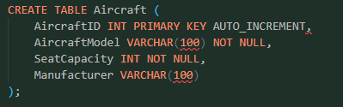
Figure 3.1. Auto Increment identifiers
Cascading delete rules were implemented to automatically remove related records when parent records are deleted. For an instance, deleting or removing a flight also removes associated bookings and payments related to deleted flight.
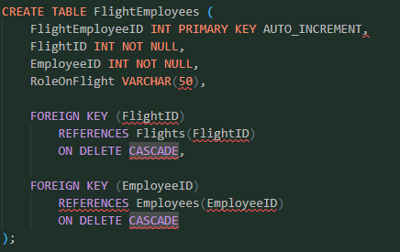
Figure 3.2. Cascading delete rules
Data insertion SQL scripts were created to insert proper data and populate database with sample data for testing and demonstration purposes. The inserted data includes airports, flights, passengers, bookings, employees and payments. Also data shapes are used as they are in real life, such as airport codes, names, flightID, numbers and etc...
Such data was provided from open data sources such as OpenFlights and Kaggle Airline Dataset.

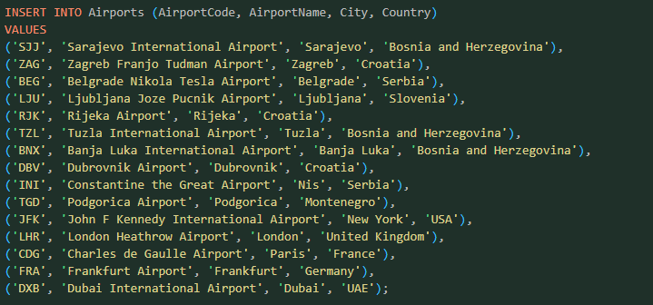
Figure 3.3.Insertion script example
9.Sample SQL Queries
For proper demonstration of functionality of whole database design, project required to test or sample queries that will show wanted data from design and to verify coordination and relationship between tables. For good checks of realtime work of Airline Reservation System database, queries included keywords such as SELECT, COUNT, JOIN, GROUP BY and etc...
To ensure that all checks are done properly and to be fully sure that database works well, five queries are utilized to test, so implemented queries were:
9.1. Passengers Per Flight
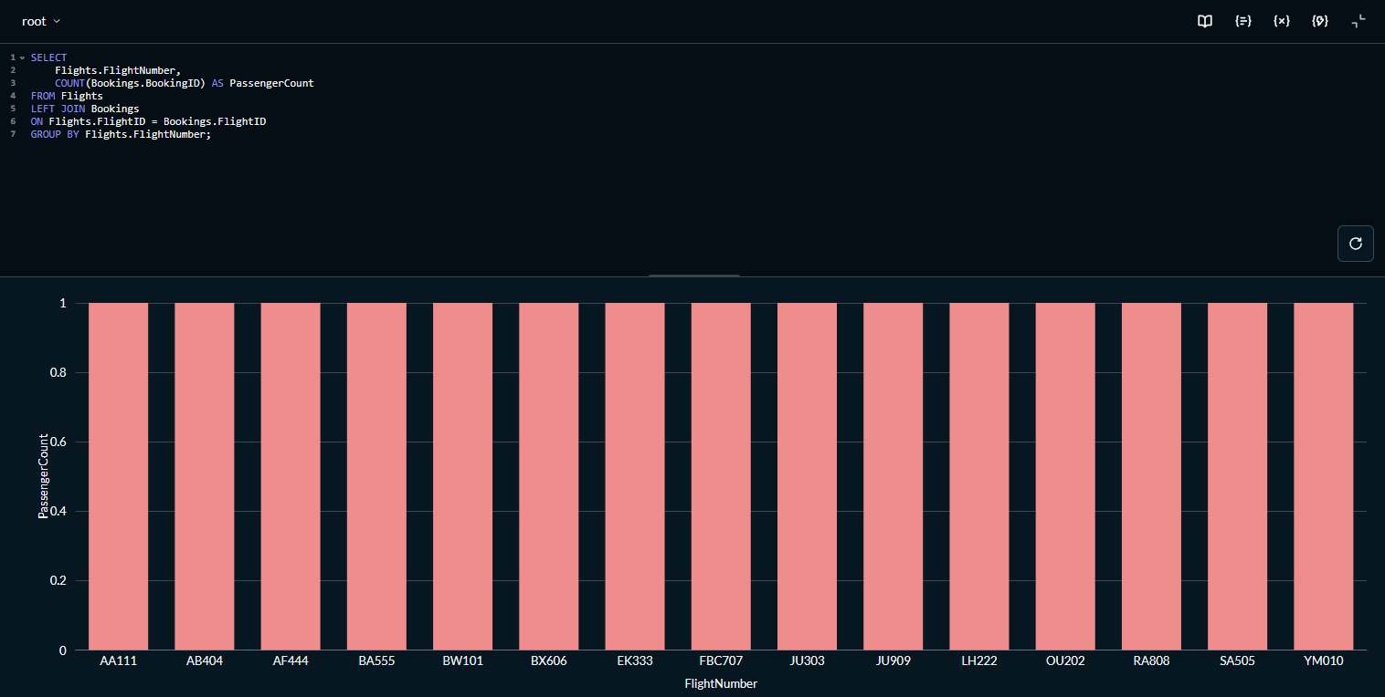
Figure 4.1. Passengers per flight (Metabase Bar Visualisation)
9.2.Revenue per Airline
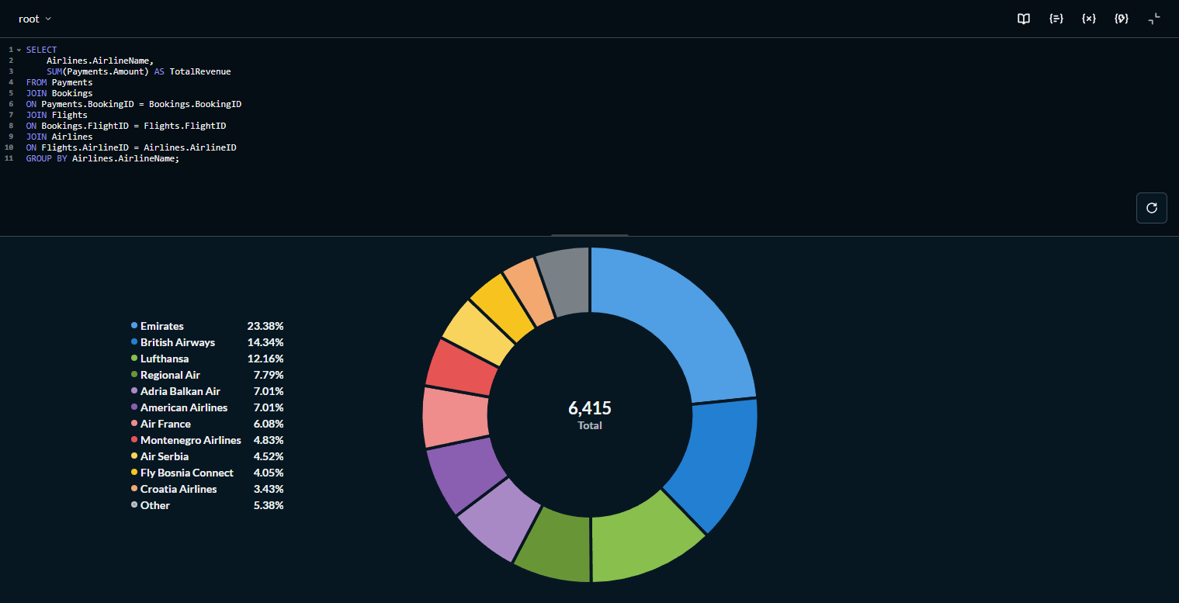
Figure 4.2. Revenue per airline (Metabase Pie Visualisation)
9.3.Delayed Flights (with minutes of delay)
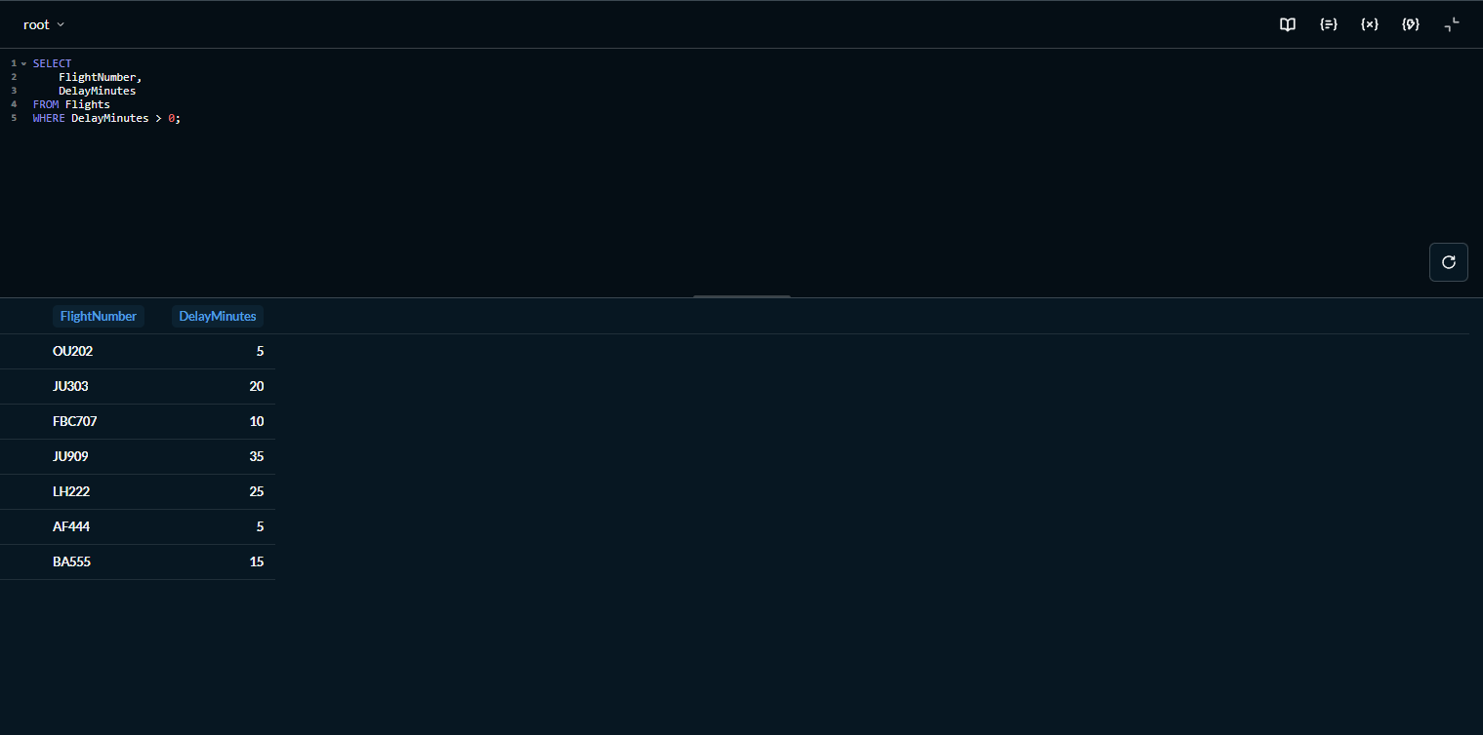
Figure 4.3. Delayed flights (Metabase Table Visualisation)

9.4.All Flights and Airports
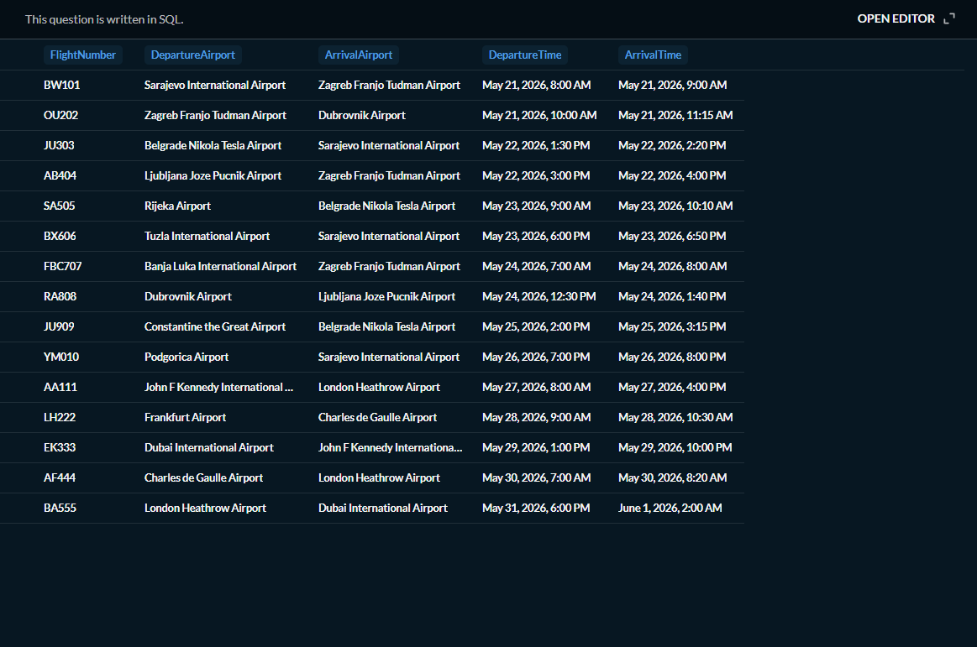
Figure 4.4. All Flights and Airports (Metabase Table Visualisation)
9.5. Revenue Per Flight
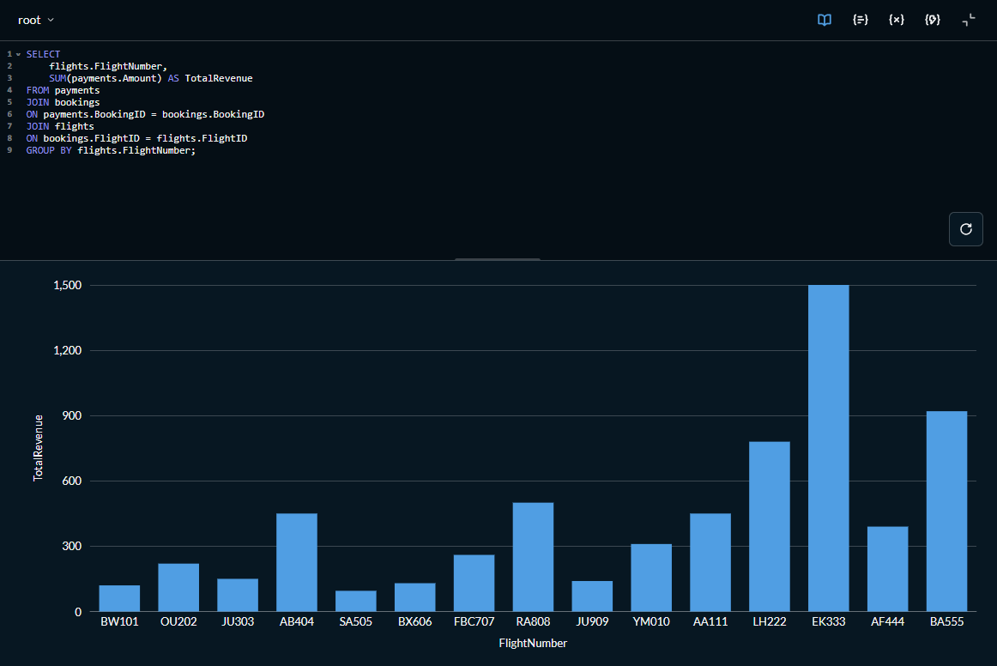
Figure 4.5. Revenue per Flight (Metabase Chart Visualisation)
9.6.Reporting and Visualisation
Metabase was used to create visual reports and analytics for the database. To summarize, following reporting or queries were tested or utilized:
- Passengers per flight
- Revenue per airline
- Delayed flights
- All flight and airports
- Revenue per flight
Charts and dashboards are showed for better and easier understanding of queries results, data and trends.

10.Tools and Technologies
10.1.MySQL
MySQL was used as the primary relational system for implementing the Airline Reservation System database. It was used to create tables, relations and execute SQL queries.
10.2.MySQL Workbench
MySQL Workbench was used as the graphical interface for usage of SQL, development and administration. Also as technical part, it was used for writing SQL scripts, managing schemas, inserting data and creating and generating image of Entity Relational Diagram.
10.3.Metabase
Metabase was used for visualising reports, dashboards based on the data that appeared as a result of queries. Visualisation of queries results allowed easier analysis and understanding of queries and general workflow of Airline Reservation System
10.4.Visual Studio Code
Visual Studio Code was used as the development environment for organizing SQL files, documentation and scripts. Also it provided integration with Git and Github for version control.
10.5. GitHub
GitHub was used for project version control and repository creation and management. It allowed storing, creating, commiting and pussing scripts and all necessary files, ER diagrams into organized directory structure and repository.

11. Challenges and solutions
Several challenges were encountered during development of the Airline Reservation System database project. Main challenge involved foreign key constraint issues by inserting related data before parent records existed. Additional problems occured with the correct order of data insertion, since relational tables depended on each other trough relationshps. Implementing many-to-many relationship between flights table and employee table also required additional redesign and introducement of junction tables. One of the challenges involved configuring Metabase and providing proper credentials during integration with MySQL as localhost didnt work. Furthermore, several improvements of database normalization and reduction of redundancy. All of challenges faced on the way to create final database design for Airline Reservation System project were successfully resolved trough multiple redesigns, debugs, and checks in developing phase.
12.Conclusion
Project demonstrates the design and usage of a relational database management system for airline reservation operations. Database supports flight scheduling, passenger management, bookings, assignments of employees and certain trackings while keeping consistency trough normalisation and establishment of proper workflow. In this project it is demonstrated practical use of SQL capabilities and queries.
Finally, project provided valuable hands-on experience in database design, general knowledge and sense of using and designing good database, SQL utilization for business-oriented system and purpose.
13.References
13.1. OpenFlights Database: openflights.org
13.2. Kaggle Dataset: www.kaggle.com
13.3.MySQL Documentation: https://dev.mysql.com/doc/
13.4.Metabase Documentation: https://www.metabase.com/docs/latest/
13.5. MySQL Workbench Documentation:
https://dev.mysql.com/doc/workbench/en/?utm_source=chatgpt.com
13.6. Course Lectures Slides and Materials:
Course lecture slides and materials provided by Dr. Kazeem Oladejo for CS306 – Database Management course. Also, additional instructions, explanations and examples discussed during lectures and tutorials of CS306 course at the International University of Sarajevo.
14. GitHub Repository
The complete project structure including SQL scripts, queries, diagram and documentaions was organised and stored using a GitHub repository. Whole repository is accessible via link provided:
https://github.com/plavovic/airlinereservationsystem

